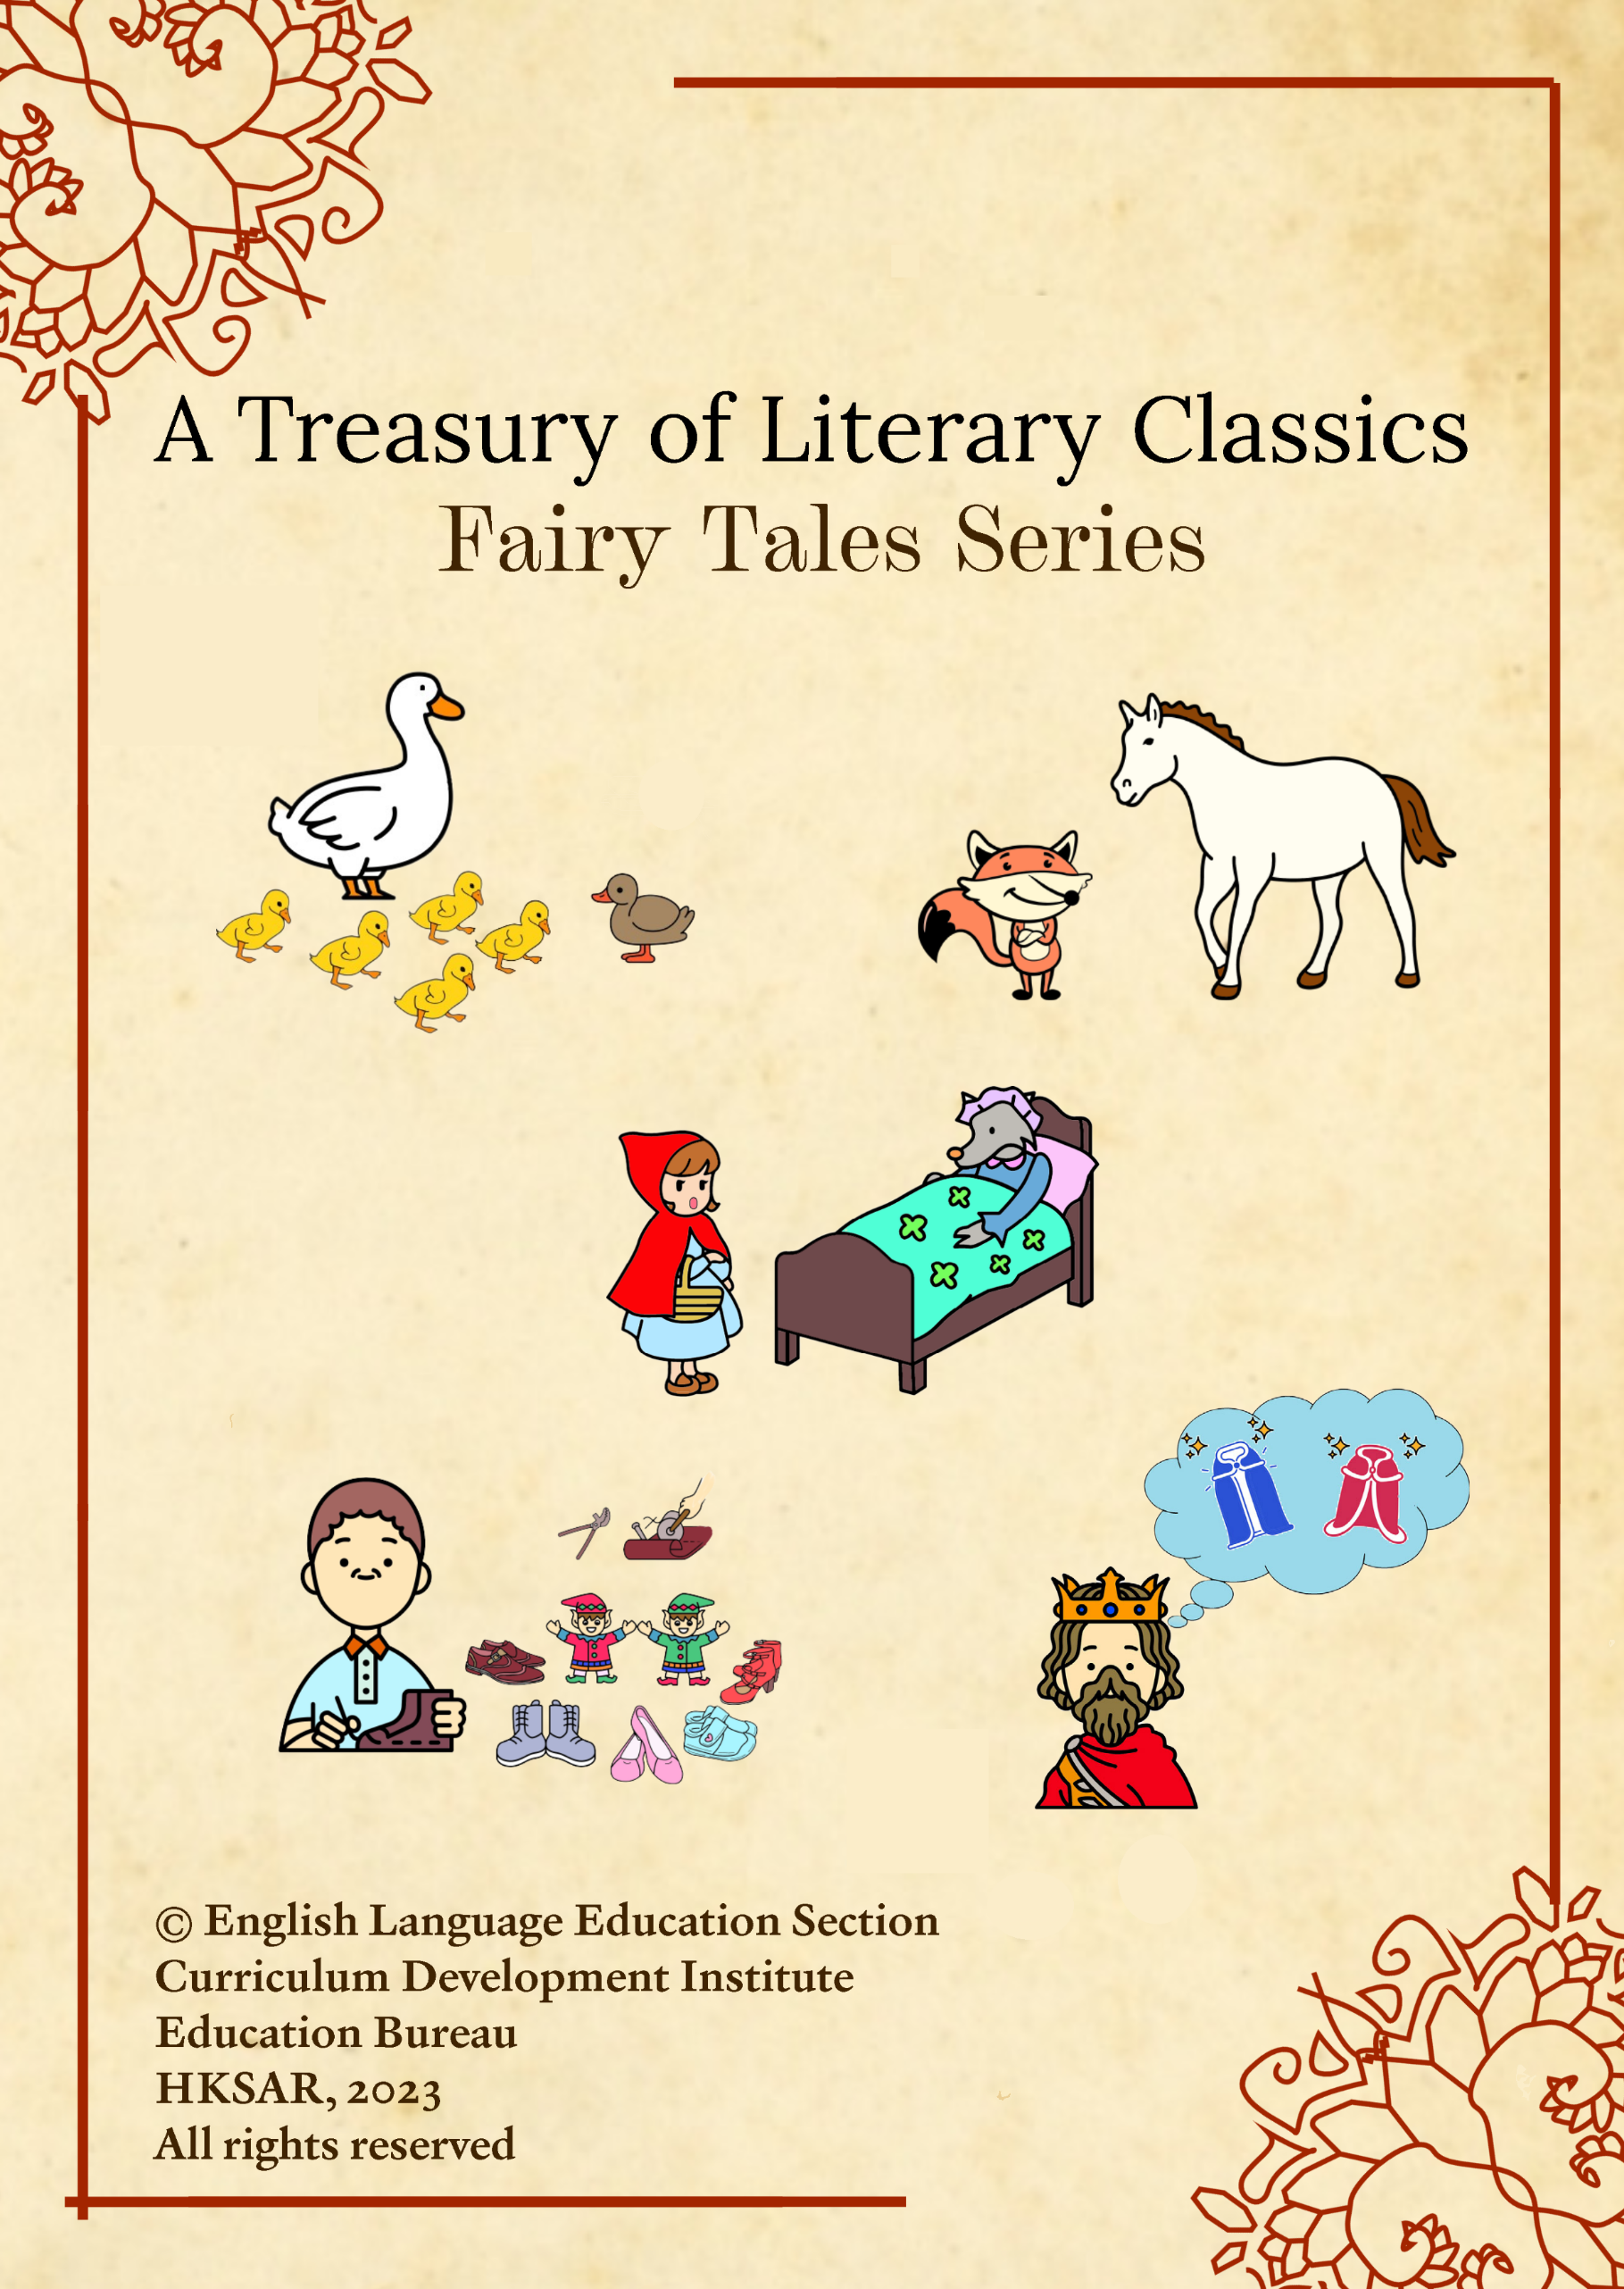

Questions

Fairy Tales Series
About fairy tales
Fairy tales, which usually involve magic and legendary deeds, are often stories intended for children. Fairy tales are traditional stories passed on through generations before being recorded in books.

Fairy tales often have a moral in the story. They usually teach about consequences and virtues such as honesty, kindness and patience. Teaching children with fairy tales helps nurture their positive values and attitudes and expands their imagination to think beyond expected boundaries. A lot of fairy tales are shared across cultures. Reading fairy tales from different corners of the world can boost children’s cultural literacy, motivate them to read more extensively, and develop their skills to use language creatively.

The five fairy tales selected in this series are works of famous German, Danish and French writers. They are tasters that aim to develop children’s emotional well-being, teach them to appreciate the beauty of language arts, and explore the wider world.

- “The Elves and the Shoemaker” by the Brothers Grimm
- “The Fox and the Horse” by the Brothers Grimm
- “The Emperor’s New Clothes” by Hans Christian Andersen
- “The Ugly Duckling” by Hans Christian Andersen
- “Little Red Riding Hood” by Charles Perrault

English Language Education Section
Curriculum Development Institute
Education Bureau
The Hong Kong Special Administrative Region

12/F, Wu Chung House, 213 Queen’s Road East, Wan Chai, Hong Kong

Published 2023

The copyright of the materials in this series belongs to the Education Bureau of the Hong Kong Special Administrative Region.

Duplication of materials in this series is restricted to non-profit-making educational purposes only. In all cases, proper acknowledgements should be made. Otherwise, all rights are reserved, and no part of these materials may be reproduced, stored in a retrieval system, or transmitted in any form or by any means without the prior permission of the Education Bureau of the Hong Kong Special Administrative Region.

© 2023

Contents

Introduction | i

- The Elves and the Shoemaker | 1
- The Fox and the Horse | 5
- The Emperor’s New Clothes | 9
- The Ugly Duckling | 14
- Little Red Riding Hood | 19

The Elves and the Shoemaker
by the Brothers Grimm

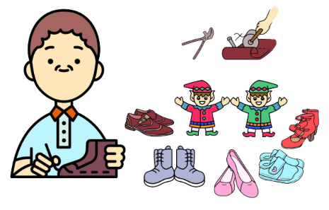
The Brothers Grimm, Jacob Ludwig Carl Grimm (4 January, 1785 – 20 September, 1863) and Wilhelm Carl Grimm (24 February, 1786 – 16 December, 1859) were German academics, folklorists and linguists. They collected and published folklore during the 19th century. They were the first and best-known collectors of German and European folk tales and popularised traditional oral tales such as “Cinderella”, “The Frog Prince”, “Hansel and Gretel” and “Snow White”.

Rewritten story

Read the story and answer the following questions.

- Once there was a shoemaker. He worked very hard but was still very poor. He was left with just enough leather to make a single pair of shoes. He cut the leather out before he went to bed. The next morning, he got up early and started working. To his amazement, the shoes were completely finished. They were made with excellent workmanship. “What happened?” he wondered.

- The same day a customer entered the shop. When he saw the pair of new shoes, he was attracted to them. The shoes looked so well on him that he willingly paid a high price. The shoemaker could now buy enough leather for two pairs of shoes. He cut out the leather before going to bed. The next morning he was again greatly surprised to find the shoes finished. Soon buyers came and they bought the shoes. The money was enough for buying leather for four pairs of shoes. He again cut out the leather at night time. As before, at daybreak, the cut-out leather had been turned into shoes of excellent workmanship. This went on for some time, and the shoemaker became rich.

- It was soon Christmas time. The shoemaker chatted with his wife. He said, “It’s really baffling what happened in the night that turned the leather into such fine shoes! I would like to sit up and watch tonight to find out who comes and does the work for me.” His wife thought it was a good idea because she was curious too. They left a candle burning and hid themselves behind a curtain in a corner of the room.

- As soon as the clock struck twelve, in came two little naked dwarfs. They sat down at the shoemaker’s bench, took up all the leather that was cut out, and began to work diligently, stitching, sewing and hammering with their nimble fingers and flying hands. The shoemaker and his wife were fascinated and could not take their eyes off them. The little elves went on and on. Before daybreak, the shoes were all finished. The elves then left hurriedly.

- The wife said to her husband, “These little elves have made us wealthy. We ought to show them our gratitude. It pains my heart to see them run about without any clothes on, especially in this freezing cold.” She suggested, “I’ll sew some shirts, undershirts, trousers and jackets for them, and knit a pair of stockings for each of them. You’ll make each of them a pair of shoes.” The good cobbler agreed with his wife. One evening, all these things were ready. The couple laid them on the bench. They then hid themselves behind the curtains and waited. At midnight the elves appeared as usual. When they prepared to work, they found the presents. At first they were puzzled, but they were soon overjoyed. They dressed themselves in the twinkling of an eye and looked at each other. They hopped and danced and sang merrily. At last they danced out of the house, and were seen no more. The good couple missed them. From then on, everything went well with the couple.

- At the beginning, how many pairs of shoes could the shoemaker make with the leather he had?
- He could make one pair of shoes.
- He could make two pairs of shoes.
- He could make three pairs of shoes.
- He could make four pairs of shoes.
Explanation / Hints
Read paragraph 1.
“He was left with just enough leather to make a single pair of shoes.”

- Why was the shoemaker able to buy leather for two pairs of shoes later?
- The elves put some money on the table for the shoemaker to buy more leather.
- The shoemaker took some leather from other shoe shops.
- The buyer liked the shoes very much and gave the shoemaker more money for them.
- The shoemaker’s wife bought some leather from the market.
Explanation / Hints
Read paragraph 2.
“The shoes looked so well on him that he willingly paid a high price. The shoemaker could now buy enough leather for two pairs of shoes.”

- Which of the following is NOT TRUE about the elves?
- The elves were very small.
- The elves did not wear clothes.
- The elves worked for the shoemaker and his wife during the night.
- The elves were unable to speak.
Explanation / Hints
Read paragraphs 4 and 5.
“As soon as the clock struck twelve, in came two little naked dwarfs. They sat down at the shoemaker’s bench, took up all the leather that was cut out, and began to work diligently, stitching, sewing and hammering with their nimble fingers and flying hands.”
“They hopped and danced and sang merrily.”

- The shoemaker’s wife said, “These little elves have made us wealthy. We ought to show them our gratitude.” How did the elves help the shoemaker and his wife become rich?
- They gave leather to the shoemaker and his wife to sell.
- They stitched shoes for the shoemaker and his wife to sell.
- They sold shoes for the shoemaker and his wife.
- They gave money to the shoemaker and his wife.
Explanation / Hints
Read paragraphs 1 and 2.
“The next morning, he got up early and started working. To his amazement, the shoes were completely finished. They were made with excellent workmanship.”
“Soon buyers came and they bought the shoes.”…“This went on for some time, and the shoemaker became rich.”

- How did the elves work? Put the events in the correct order.
- They took the leather which was cut out beforehand.
- They sat down by the shoemaker’s table.
- They stopped when all the work was done.
- They began to stitch, sew and hammer the leather to make new shoes.
- (i) (ii) (iii) (iv)
- (ii) (iii) (iv) (i)
- (ii) (i) (iv) (iii)
- (iv) (iii) (i) (ii)
Explanation / Hints
Read paragraph 4.

- What did the shoemaker and his wife do to thank the elves?
- They cooked some delicious food for the elves.
- They made some little clothes and shoes for the elves.
- They made a lot of shoes for the elves.
- They sang some songs to the elves.
Explanation / Hints
Read paragraph 5.
“She suggested, ‘I’ll sew some shirts, undershirts, trousers and jackets for them, and knit a pair of stockings for each of them. You’ll make each of them a pair of shoes.’ The good cobbler agreed with his wife. One evening, all these things were ready.”

- Three types of verbs can be found in stories. They are saying verbs, action verbs and thinking verbs.
Saying verbs are verbs that we use to report what the characters said, e.g. “said” in “He said, ‘It’s really baffling what happened in the night that turned the leather into such fine shoes!’ ”
Action verbs are verbs that we use to show what the characters did, e.g. “cut” in “He cut the leather out before he went to bed.”
Thinking verbs are verbs that we use to show the characters’ feelings and thoughts, e.g. “wondered” in “ ‘What happened?’ he wondered.”

Read the following descriptions and the words underlined. Identify the correct type of verb from the list given.
- Saying verbs B. Action verbs C. Thinking verbs

 | Description | Type of verb
7a. | Soon buyers came and they bought the shoes. (Paragraph 2) | ( )
7b. | His wife thought it was a good idea because she was curious too. (Paragraph 3) | ( )
7c. | As soon as the clock struck twelve, in came two little naked dwarfs. (Paragraph 4) | ( )
7d. | She suggested, “I’ll sew some shirts, undershirts, trousers and jackets for them, and knit a pair of stockings for each of them. You’ll make each of them a pair of shoes.” (Paragraph 5) | ( )
Explanation / Hints
Read the sentences carefully to understand their meanings.

- Which of the following is the best description for the shoemaker and his wife?
- They were thankful.
- They were curious.
- They were reliable.
- They were brave.
Explanation / Hints
Read paragraph 5.
“The wife said to her husband, ‘These little elves have made us wealthy. We ought to show them our gratitude …’ ”

- How did the elves feel when they first saw the presents?
- Curious
- Pain
- Joyful
- Confused
Explanation / Hints
Read paragraph 5.
“At first they were puzzled, but they were soon overjoyed.”

Extension: Time to think!
- What is the moral lesson of the story?

- Do you have a family member or a friend who always helps you? What does this person say to you or do for you? Think and share with your parents or classmates.
The Fox and the Horse
by the Brothers Grimm
Rewritten story

Read the story and answer the following questions.

- Once there was a horse. He used to be a faithful servant to a farmer, but as he grew older and weaker, he could not work as well as before. His master no longer wanted to give him food and was even determined to drive him away. One day, the farmer said, “You’re no longer useful to me and I won’t keep you. However, if you can prove yourself stronger than a lion and bring one to me, I’ll take you back and let you have enough to eat.” He then chased the horse into the open country. The poor horse felt miserable and depressed. He hung his head very low and wandered up and down in the forest.

- After a while, he met a fox. “What’s the matter? Why are you looking so miserable wandering in this cold wind and rain?” asked the fox.

- “Alas,” sighed the horse, “My master has forgotten the work I’ve done for him for so many years. Now that I cannot plough well, he has stopped feeding me and driven me away. He said if I could prove myself stronger than a lion by bringing one to him, he would keep me. What chance can I have of that?” The horse was tearful.

- The fox offered, “I’ll help you. Just lie down, stretch yourself out stiffly as if you were dead, and do not move.” The horse did as he was told.

- The fox then went to the lion, who had his cave not too far away. He told the lion, “A large dead horse is lying outside. Come with me and you can eat to your heart’s desire!” The lion was pleased and followed him. When they were standing by the horse, the fox said, “It’s not comfortable for you to start your delicious meal here. There are eagles circling in the sky above. I’ll fasten the horse to you by the tail, and you can drag it to your cave and eat it in peace.” The lion agreed and lay down for the fox to tie the horse to him. But the fox tied the lion’s legs together with the horse’s tail, and twisted and fastened the tail so tightly that the lion could not break loose. The fox then tapped the horse on the shoulder and said, “Pull hard and off you go!” The horse sprang up and dragged the lion after him. The lion was shocked and furious. He roared so loudly that all the birds in the forest flew out in all directions. The horse kept pulling the lion after him over the country until he arrived at his master’s doorstep. The master opened the door and was greatly surprised to see the horse and the lion. He kept his word and let the horse stay and have plenty to eat until he died.
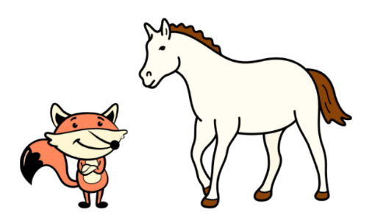

1. Why did the master no longer want to give food to his horse?
- The master did not have enough food for his horse.
- The master punished his horse by giving it no more food.
- The master thought his horse was old and useless. Thus he didn’t want to feed it.
- The master gave all the food to another new horse.
Explanation / Hints
Read paragraph 1.
“Once there was a horse. He used to be a faithful servant to a farmer, but as he grew older and weaker, he could not work as well as before. His master no longer wanted to give him food and was even determined to drive him away. One day, the farmer said, ‘You’re no longer useful to me and I won’t keep you …’ ”

- What did the master ask the horse to do to show it was still strong?
- The horse had to kill a lion and bring it to the master.
- The horse had to bring another horse to the master.
- The horse had to bring a fox to the master.
- The horse had to bring a lion to the master.
Explanation / Hints
Read paragraph 1.
“One day, the farmer said, ‘… However, if you can prove yourself stronger than a lion and bring one to me, I’ll take you back and let you have enough to eat.’ ”

- Which adjective best describes the attitude of the master when he drove his horse away?
- Caring
- Selfish
- Responsible
- Reliable
Explanation / Hints
Read paragraph 1.
“Once there was a horse. He used to be a faithful servant to a farmer, but as he grew older and weaker, he could not work as well as before. His master no longer wanted to give him food and was even determined to drive him away.”
What did the master do to his faithful horse?

- What did the fox ask the horse to do?
- The fox asked the horse to pretend to be dead.
- The fox asked the horse to make friends with a lion.
- The fox asked the horse to look for a lion together.
- The fox asked the horse to set a trap to kill a lion.
Explanation / Hints
Read paragraph 4.
“The fox offered, ‘I’ll help you. Just lie down, stretch yourself out stiffly as if you were dead, and do not move.’ ”

- Which adjectives best describe how the fox trapped the lion?
- Shy
- Reliable
- Dishonest
- Cunning
- (i) & (ii)
- (iii) & (iv)
- (i), (ii) & (iii)
- All of the above
Explanation / Hints
Read paragraph 5.
“… the fox said, ‘It’s not comfortable for you to start your delicious meal here. There are eagles circling in the sky above. I’ll fasten the horse to you by the tail, and you can drag it to your cave and eat it in peace.’ The lion agreed and lay down for the fox to tie the horse to him. But the fox tied the lion’s legs together with the horse’s tail, and twisted and fastened the tail so tightly that the lion could not break loose.”
Did the fox keep his words?

- Why did the horse follow what the fox told it to do?
- The fox had helped the horse before.
- The fox knew where the lion’s cave was.
- The horse misunderstood the fox’s suggestion.
- The horse had nobody to rely on except the fox.
Explanation / Hints
Read paragraphs 2 and 3.
Did the horse get help from others?

- Sensory details including sight, sound, touch, smell and taste can make the description more vivid. Read the following descriptions and the words underlined. Identify the correct sensory detail from the list given. Each option can be used once only.

A. Sound B. Sight C. Touch D. Taste

 | Description | Sensory detail
7a. | “Why are you looking so miserable wandering in this cold wind and rain?” asked the fox. (Paragraph 2) | ( )
7b. | He told the lion, “A large dead horse is lying outside. Come with me and you can eat to your heart’s desire!” (Paragraph 5) | ( )
7c. | It’s not comfortable for you to start your delicious meal here.  (Paragraph 5) | ( )
7d. | The lion was shocked and furious. He roared so loudly that all the birds in the forest flew out in all directions. (Paragraph 5) | ( )
Explanation / Hints
Read the sentences carefully to understand their meanings.

- What sensory details are described in the following sentence?
“While hiking in the mountain, Christy enjoyed the fresh air and the pleasant scent of flowers.”
- Sight
- Touch
- Taste
- Smell
Explanation / Hints
What does the word “scent” tell you about the flowers?

- Which of the following is NOT TRUE about the horse?
- The horse was young.
- The horse had worked for its master for a long time.
- The horse hung its head down because it was upset.
- The horse dragged a lion to its master.
Explanation / Hints
Was the horse young?
What did the master do to the horse?

Extension: Time to think!
- What is the moral lesson of the story?

- Do you keep a pet at home? If your pet gets old, what will you do to it? Think and share with your parents or classmates.
The Emperor’s New Clothes
by Hans Christian Andersen

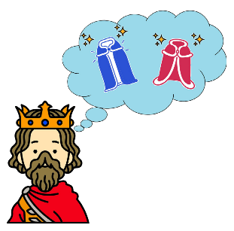
Hans Christian Andersen (2 April, 1805 – 4 August, 1875) was a Danish author who wrote a lot of famous fairy tales, including “The Little Mermaid”, “The Little Match Girl” and “The Princess and the Pea”. His stories have achieved worldwide popularity and inspired ballets, plays, animated and live-action films.

Rewritten story

Read the story and answer the following questions.

- A long long time ago, an emperor was very fond of new clothes. The only thing important to him was to be well dressed every day. He wanted to appear before everybody in beautiful new clothes. The only thing his people could say about him was that “The emperor is in his dressing room trying on new clothes.”

- One day, two swindlers from other places arrived in the country. They pretended to everyone that they were weavers and that they could make the finest cloth in the world. They boasted, “The colours and patterns are very beautiful and the material is so special that it is invisible to stupid persons.”

- The emperor thought that he must have clothes made of this wonderful material. He could then wear them and find out the stupid people. He invited these two rascals to his palace and gave them a large sum of money so that they would start working at once. They asked for the finest silk and the most precious gold-cloth. They then hid away the expensive material and pretended to be working very hard at the empty looms from dawn till late at night.

- The emperor would like to know how the weavers were getting on with the cloth, so he sent someone to find out first.

- The emperor sent his honest old minister to the weavers. When the old minister arrived, he saw the swindlers sitting before the empty looms. He only saw the looms spinning but could not see anything on them. He felt worried but did not say anything. The swindlers asked, “How do you find the cloth?” “Oh, it’s really beautiful. I’ll tell the emperor.”

- “How clever you are!” the two weavers described to him the colours and pattern. The minister listened carefully so that he could tell the emperor what the cloth looked like. They continued to pretend to be working busily at the empty looms.

- The emperor sent another minister to see how the weavers were getting on. This second minister also could see nothing. Nevertheless, he praised the beautiful colours and pattern of the cloth. “The cloth is brilliant,” he told the emperor. The emperor wanted to see it himself. He went to the two swindlers, who were very busy at the looms, but without using any thread. The two ministers who had been there before said to the emperor, “Isn’t it magnificent? Your Majesty must be very pleased with the colours and pattern.”

- “I don’t see anything at all. Am I stupid?” thought the emperor. Yet he said to the weavers, “Your cloth is fantastic.” His ministers advised him to wear the magnificent new clothes at a great procession the next day. The two rascals stayed up the whole night to finish the emperor’s new clothes.

- The next morning, the swindlers lifted their arms as if they were holding something in their hands. “How brilliant the coat is!” “Here are the trousers!” They continued to say, “They are all as light as a cobweb.” The emperor put the new clothes on. He could not feel the weight of the clothes. He looked at himself in the mirror from all sides, as if he was admiring his new suit. All his attendants said, “How well the suit looks on you! How well it fits!”

- It was time for the procession. The emperor was escorted by a large number of attendants. People were dying to see him and the streets were lined with crowds on both sides. The people exclaimed, “How beautiful and magnificent the emperor’s new suit is!” Though they saw nothing, nobody would admit it, as this would mean they were stupid.

- A little boy was in the crowd with his father. He said to his father, “Look! He is not wearing anything! He is completely nude!” Many people nearby as well as the emperor could hear unmistakably. “I’m most sorry about that”, his father was very embarrassed. “He is a small kid who knows nothing.” But the crowd was whispering. “He does have nothing on at all!” All the people realised the truth. The emperor knew the truth, but he could only go on until the procession ended.

- The emperor tried to show off his new clothes. The people, however, greeted him with laughter and teasing. Afterwards, he sent his soldiers to arrest the two swindlers, but they had disappeared with all the money and precious material.

- What was the most important to the emperor?
- He only wanted to have a lot of money.
- He only wanted to make his own clothes.
- He only wanted to win in battles.
- He only wanted to wear new clothes.
Explanation / Hints
Read paragraph 1.
“A long long time ago, an emperor was very fond of new clothes. The only thing important to him was to be well dressed every day. He wanted to appear before everybody in beautiful new clothes.”

- What did the emperor do in his dressing room?
- The emperor liked working in his dressing room.
- The emperor spent all his time trying on new clothes in his dressing room.
- The emperor had meetings in his dressing room.
- The emperor made new clothes in his dressing room.
Explanation / Hints
Read paragraph 1.
“A long long time ago, an emperor was very fond of new clothes. The only thing important to him was to be well dressed every day. … The only thing his people could say about him was that ‘The emperor is in his dressing room trying on new clothes.’ ”

- According to the two weavers, what was special about the clothes they made?
- The clothes were visible only to smart people.
- The clothes were invisible only to smart people.
- The clothes were touchable only by smart people.
- The clothes were fashionable only to smart people.
Explanation / Hints
Read paragraph 2.
“One day, two swindlers from other places arrived in the country. They pretended to everyone that they were weavers and that they could make the finest cloth in the world. They boasted, ‘The colours and patterns are very beautiful and the material is so special that it is invisible to stupid persons.’ ”

- How did the emperor make the two weavers start working on his clothes?
- The emperor helped them set up a lot of looms.
- The emperor bought them a lot of clothes.
- The emperor sent them a lot of wardrobes.
- The emperor gave them a lot of money.
Explanation / Hints
Read paragraph 3.
“He invited these two rascals to his palace and gave them a large sum of money so that they would start working at once.”

- Which of the following sentences are TRUE about the weavers?
- The weavers came to the town from other places.
- The weavers said that they could make the finest cloth.
- The weavers asked for the finest silk and the most precious gold-cloth.
- The weavers worked really hard in making the suit for the emperor.
- (i), (ii) & (iii)
- (i), (ii) & (iv)
- (i), (iii) & (iv)
- (ii), (iii) & (iv)
Explanation / Hints
Read paragraphs 2 and 3.
“One day, two swindlers from other places arrived in the country. They pretended to everyone that they were weavers and that they could make the finest cloth in the world.”
“They asked for the finest silk and the most precious gold-cloth. They then hid away the expensive material and pretended to be working very hard at the empty looms from dawn till late at night.”

- Why did the emperor send an old minister to look at the cloth?
- The emperor thought that the old minister was honest.
- The emperor was unable to look at the cloth himself.
- The emperor thought that he was unfit to look at the cloth himself.
- The emperor wanted to find out who was stupid.
Explanation / Hints
Read paragraph 5.
What did the emperor think about the old minister?

- The writer uses the simile “as light as a cobweb” to describe the emperor’s new suit. A simile is a way to compare one thing with another using “as …as” or “like …”. For example, “as wise as an owl” (very clever) or “like a bag of bricks” (very heavy).

Read the following descriptions. Fill in each blank with a simile from the list given. Each option can be used once only.
- as quiet as a mouse B. as cunning as a fox C. as red as a beetroot D. as brave as a lion

 | Description | Simile
7a. | The weavers claimed that they could make magnificent clothes, but in fact they did not know how. The weavers were ___. | ( )
7b. | A little boy told the emperor the truth while all the other people said nothing. The little boy was ___. | ( )
7c. | The emperor thought he was naked but he did not know what to do. The emperor’s face was ___. | ( )
7d. | None of the assistants made a sound when someone told the emperor the truth honestly. They were ___. | ( )
Explanation / Hints
- “As quiet as a mouse” refers to someone who makes no noise or says nothing.
- “As cunning as a fox” refers to someone who tricks others in order to get something for oneself.
- “As red as a beetroot” refers to someone who is red in the face because he or she is feeling very embarrassed about something.
- “As brave as a lion” refers to someone who does dangerous things without fear.

- When the two weavers had helped the emperor put on the new clothes, why did the emperor look at himself in the mirror from all sides?
- He wanted to see how he looked in the new clothes.
- He wanted to show the people around him that he could see his beautiful new clothes.
- He thought that only he himself could see his new clothes and he was very pleased.
- He wanted to add accessories onto his new suit.
Explanation / Hints
Read paragraph 9.
“The emperor put the new clothes on. He could not feel the weight of the clothes. He looked at himself in the mirror from all sides, as if he was admiring his new suit.”

- When the emperor put on the new suit, the weavers said it was “as light as a cobweb”. What does “as light as a cobweb” mean?
- It means the suit was bright.
- It means there was a light on the suit.
- It means the suit was very light.
- It means there was a spider-web on the suit.
Explanation / Hints
Read paragraph 9.
How did the emperor feel after wearing the new suit?

Extension: Time to think!
- What is the moral lesson of the story?

- If you were the little child, would you do the same? Why or why not? Think and share with your parents or classmates.

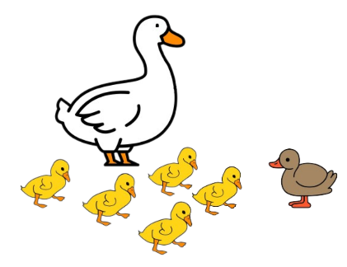
The Ugly Duckling
by Hans Christian Andersen
Rewritten story

Read the story and answer the following questions.

- There once was a mother duck. She eagerly waited for her babies to hatch. At last, the mother duck watched the yellow ducklings step out of the shells one by one. However, there was a large egg still in the nest.

- Two days later, the big egg started to crack and out came a baby boy. He was brownish grey, large and odd-looking, with a long beak, scruffy feathers and an ugly face! “He doesn’t look like us and is ugly!” exclaimed a duckling. Though the duckling looked different, the mother duck would love him the same. She told her little ones, “Let’s all go to the pond and I’ll teach you all the ways of being a duck.”

- “Quack! Quack! Ugly! Ugly!” One duckling pointed at his youngest brother and the other ducklings joined in. The ugly duckling did not know why they yelled at him. He followed his mother and jumped into the pond. Though he wanted to play with his brothers and sisters, the ducklings shouted, “Go away! Don’t stay with us!” The mother duck was sad. She told her baby ducklings to be kind to their brother, but could do nothing else.

- A few days passed. The little ducklings and their mother were in the pond again. There were other ducks nearby and they stared at the ugly duckling and jested, “What is this? Have you ever seen such an ugly duck? I wonder what he is!” They burst into laughter. A duck swam by and pecked at the ugly duckling. His mother made him stay away from the others. The ugly duckling knew his mother was embarrassed. He decided to leave. One night, he flew over the fence and out of the farmyard. He waddled through tall river reeds and marsh plants. He waddled through the mud. All this made him very dirty. He then reached a lake where a family of geese lived. The goslings were brownish grey just like him. He was happy and swam towards the family of geese. “Hello there! May I join you?” said the ugly duckling.

- “Who are you?” asked the father goose and mother goose.

- “You’re really ugly!” the goslings said all at once.

- When the ugly duckling decided to leave them, the father goose greeted him and said, “You sure are strange looking, but you’re welcome to join our family.” The father goose and mother goose were kind to him and he played happily with the goslings. Happy days did not last long, however. One day, a hunter and his basset hound approached the lake. The hunter fired a shot, which did not hit any of the geese but they flew off in fear. The ugly duckling was both sad and frightened.

- He wandered off to look for a family to take him in. After a few days, he was discovered by a farmer and his wife who lived in a cottage. They decided to keep the ugly duckling because they wanted him to lay eggs for them to eat. They waited for the ugly bird to lay eggs. They waited and waited, but nothing happened. They did not want to keep the ugly duckling anymore. They told him to go away. He thought to himself, “Nobody wants me,” and was in tears.

- It was winter and difficult to find food in the lake. Still, the ugly duckling tried hard and miraculously he survived the cold winter. Spring came and he found a new lake. He saw a family of the most beautiful birds he had ever seen – swans. At that moment, a swan glided gracefully through the water towards the ugly duckling. “My, my! How handsome you are! I’ve never seen such white feathers! How they dazzle under the sun!”

- The ugly duckling was confused. He went to the water and looked at his reflection, which was a very beautiful white swan, with a long and elegant neck! He could not believe his eyes. The swan asked him to join his family. All the swans said, “Stay here with us!” He flapped his wings in great joy! “I’m surely not an ugly duckling! I am now high up in the sky and can go far! Hurray!”

- What happened to the largest egg?
- It was the last egg to hatch.
- It was cooked by a farmer.
- It was the first egg to hatch.
- It was eaten by a fox.
Explanation / Hints
Read paragraphs 1 and 2.
“However, there was a large egg still in the nest.”
“Two days later, the big egg started to crack and out came a baby boy.”

- What was special about the last duckling’s beak?
- The last duckling had a little beak.
- The last duckling had a long beak.
- The last duckling had a pointed beak.
- The last duckling had a round beak.
Explanation / Hints
Read paragraph 2.
“He was brownish grey, large and odd-looking, with a long beak, scruffy feathers and an ugly face!”

- What did the ducks in the pond do to the ugly duckling?
- The ducks played with the ugly duckling.
- The ducks swam with the ugly duckling.
- The ducks laughed at the ugly duckling.
- The ducks talked to the ugly duckling.
Explanation / Hints
Read paragraph 4.
“There were other ducks nearby and they stared at the ugly duckling and jested, ‘What is this? Have you ever seen such an ugly duck? I wonder what he is!’ They burst into laughter. A duck swam by and pecked at the ugly duckling.”

- How did the mother duck feel when the ugly duckling was not welcomed by other ducks?
- The mother duck felt worried.
- The mother duck felt glad.
- The mother duck felt excited.
- The mother duck felt awkward.
Explanation / Hints
Read paragraph 4.
“His mother made him stay away from the others. The ugly duckling knew his mother was embarrassed.”

- Which of the following sentences are TRUE about the ugly duckling?
- The ugly duckling’s mother did not love him.
- The ugly duckling was large when he was hatched.
- The ugly duckling looked different from other ducklings.
- The ugly duckling did not have feathers.
- (i) & (iii)
- (ii) & (iii)
- (i), (ii) & (iii)
- (ii), (iii) & (iv)
Explanation / Hints
Read paragraph 2.
“Two days later, the big egg started to crack and out came a baby boy. He was brownish grey, large and odd-looking, with a long beak, scruffy feathers and an ugly face! … Though the duckling looked different, the mother duck would love him the same.”

- Why did the ugly duckling not stay with the geese?
- He was ugly and the father goose and mother goose did not like him.
- He was ugly and the little geese did not play with him.
- A hunter shot at the geese and all the geese flew away.
- The farmer shot at the geese and all the geese died.
Explanation / Hints
Read paragraph 7.
“The hunter fired a shot, which did not hit any of the geese but they flew off in fear. The ugly duckling was both sad and frightened.”

- Verbs such as “say” or “ask” are used to report what someone said. In the story, the writer also uses verbs in the simple past tense such as “shouted” or “exclaimed” to show more about speakers’ feelings and also thoughts.
Read the following descriptions. Fill in each blank with a verb from the list given. Each option can be used once only.

- shouted B. exclaimed C. thought D. jested

 | Description | Verb
7a. | “He doesn’t look like us and is ugly!” __________ a duckling.  (Paragraph 2) | ( )
7b. | Though he wanted to play with his brothers and sisters, the ducklings __________, “Go away! Don’t stay with us!” (Paragraph 3) | ( )
7c. | There were other ducks nearby and they stared at the ugly duckling and __________, “What is this? Have you ever seen such an ugly duck? I wonder what he is!” (Paragraph 4) | ( )
7d. | The ugly duckling __________ to himself, “Nobody wants me,” and was in tears. (Paragraph 8) | ( )
Explanation / Hints
Read the sentences carefully to understand their meanings.

- The ugly duckling met some animals and people after he left his mother. Which of the following shows the correct order?
- Geese a hunter some swans a farmer and his wife
- A hunter a farmer and his wife geese some swans
- A farmer and his wife geese a hunter some swans
- Geese a hunter a farmer and his wife some swans
Explanation / Hints
What/Who did the ugly duckling see after he left his mother? (Paragraph 4)
Why did the ugly duckling leave them? (Paragraph 7)
What/Who did the ugly duckling see afterwards? (Paragraph 8)
What/Who did the ugly duckling see when spring came? (Paragraph 9)

- How did the ugly duckling look like when he grew up?
- The ugly duckling became a white swan with a long neck.
- The ugly duckling became a grey duck with a long neck.
- The ugly duckling became a brown goose with a short neck.
- The ugly duckling became a yellow swan with a short neck.
Explanation / Hints
Read paragraphs 9 and 10.
“At that moment, a swan glided gracefully through the water towards the ugly duckling. ‘My, my! How handsome you are! I’ve never seen such white feathers! How they dazzle under the sun!’ ”
“The ugly duckling was confused. He went to the water and looked at his reflection, which was a very beautiful white swan, with a long and elegant neck!”

Extension: Time to think!
- What is the moral lesson of the story?

- When the ugly duckling was still young, other ducks were not nice to him. What would you say to these ducks? Think and share with your parents or classmates.

Little Red Riding Hood
by Charles Perrault

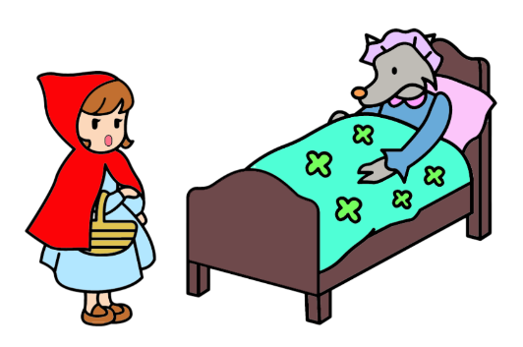
Charles Perrault (12 January, 1628 – 16 May, 1703) was a French author who wrote a lot of famous tales, including “Le Petit Chaperon Rouge” (“Little Red Riding Hood”), “Cendrillon” (“Cinderella”) and “La Belle au bois Dormant” (“The Sleeping Beauty”). Some of his works influenced the German versions published by the Brothers Grimm more than 100 years later. Many of his stories have been widely adapted to theatre, opera, ballets and films.

Rewritten story

Read the story and answer the following questions.

1. Once upon a time, there lived in a village a sweet little girl. Everyone loved her and her grandmother especially doted on her. Once her grandmother gave her a red cape with a hood. It looked so well on her that the little girl wore it all the time, and she therefore came to be known as Little Red Riding Hood.

- One day her mother said to her, “Go, my dear, to your grandmother with these cakes and soup. She was not feeling well when I last visited her. On the way, do not speak to strangers and do not leave the path, or you might fall or even lose your way.”

- Her grandmother lived in the woods, around half an hour’s walk from the village. On her way, Little Red Riding Hood met a wolf, who would very much like to eat her. The little girl stopped to speak to him. Little did she know that it was dangerous to talk to a stranger, not to mention a wolf.

- The wolf said, “Good day, little girl. Where are you going?”

- “I’m going to see my grandmother. She’s ill and I’m taking her some cakes and soup,” said Little Red Riding Hood.

- “Where does your grandmother live?”

- “Grandma lives in a house less than half an hour’s walk from here, under the three great oak trees,” answered Little Red Riding Hood.

- The wolf said, “The woods are very beautiful at this time of the year, with a lot of flowers blossoming. Why don’t you go and take a look?” The wolf thought to himself, “What a tender young creature!” His mouth watered.

- Little Red Riding Hood could see beautiful flowers of many colours. She thought to herself, “I’ll take a bouquet of these flowers to Grandma.” As she gathered flowers, she saw more beautiful flowers ahead and so she wandered further and further into the woods. Meanwhile, the wolf ran straight to the grandmother’s house. He knocked on the door: tap, tap.

10. “Who’s there?” asked Grandma. “It’s Little Red Riding Hood, Grandma,” the wolf imitated the little girl’s voice. “I’ve brought you some cakes and soup, and some flowers too.” Grandma called out, “Just press the latch.” The wolf entered, fell upon the old woman and locked her in the closet. He dressed himself in Grandma’s night gown and put on her frilly cap. His pointed ears showed, however. Then he got into her bed and pulled the curtains shut.

11. Little Red Riding Hood at last arrived at Grandma’s house, and found, to her surprise, the door standing open. She called out, “Grandma, it’s Little Red Riding Hood. How are you?” “My dear, just enter. I’m too weak to get up,” the wolf imitated Grandma’s voice.

- Little Red Riding Hood entered the house and went over to Grandma’s bed and pulled back the curtains. Grandma was lying there looking very strange.

- “Oh, Grandma, what big ears you have!”
“All the better to hear you with.”
“Oh, Grandma, what big eyes you have!”
“All the better to see you with.”
“Oh, Grandma, what big hands you have!”
“All the better to hug you with.”
“Oh, but, Grandma, what big teeth you have!”
“All the better to eat you with!”

- Suddenly, the wolf leaped onto Little Red Riding Hood, trying to gobble her up! A huntsman was just passing by and saw everything. He rushed in and fired his rifle to save the little girl. The wolf was killed. The huntsman then heard Grandma’s cry and freed her from the closet. “What a narrow escape!” cried Grandma. Little Red Riding Hood and Grandma thanked the huntsman profusely. He lifted and hauled the dead wolf over his shoulder and took leave.

- Little Red Riding Hood promised Grandma and later her mother never to go off the path and talk to strangers again.

- Why did people call the girl “Little Red Riding Hood”?
- She liked red clothes very much when she was very young.
- She was small and like her family members, she had red hair.
- She was the smallest in the family, who liked red clothes.
- She would never wear anything else once she had the red cape with a hood.
Explanation / Hints
Read paragraph 1.
“Once her grandmother gave her a red cape with a hood. It looked so well on her that the little girl wore it all the time, and she therefore came to be known as Little Red Riding Hood.”

- Why did her mother tell Little Red Riding Hood not to run off the path?
- She might break the bottle.
- She might get lost.
- She might meet a wolf.
- She might drop the cakes.
Explanation / Hints
Read paragraph 2.
“One day her mother said to her, ‘Go, my dear, to your grandmother with these cakes and soup. She was not feeling well when I last visited her. On the way, do not speak to strangers and do not leave the path, or you might fall or even lose your way.’ ”

- Where did the grandmother live?
- She lived in the woods.
- She lived on the path.
- She lived on a farm.
- She lived in a castle.
Explanation / Hints
Read paragraph 3.
“Her grandmother lived in the woods, around half an hour’s walk from the village.”

- Why did Little Red Riding Hood get deeper and deeper into the woods?
- She wanted to pick more flowers.
- She ran after the wolf.
- She chased her grandmother.
- She looked for birds.
Explanation / Hints
Read paragraphs 8 and 9.
“The wolf said, ‘The woods are very beautiful at this time of the year, with a lot of flowers blossoming. Why don’t you go and take a look?’ ”
“She thought to herself, ‘I’ll take a bouquet of these flowers to Grandma.’ As she gathered flowers, she saw more beautiful flowers ahead and so she wandered further and further into the woods.”
- On the way to her grandmother’s house, who did Little Red Riding Hood NOT meet?
- She did not meet her mother.
- She did not meet her grandmother.
- She did not meet a wolf.
- She did not meet a dog.
A. (i) & (iii)
B. (ii) & (iv)
C. (i), (ii) & (iv)
D. (ii), (iii) & (iv)
Explanation / Hints
Read paragraph 3.
“On her way, Little Red Riding Hood met a wolf, who would very much like to eat her.”

- How strange was the grandmother when Little Red Riding Hood drew the curtains back?
- The grandmother had big ears, small eyes, small hands and big teeth.
- The grandmother had small ears, big eyes, small hands and small teeth.
- The grandmother had big ears and eyes, large hands and big teeth.
- The grandmother had big ears and eyes, small hands and small teeth.
Explanation / Hints
Read paragraph 13.

- Adjectives give us more information. They describe features and qualities of people, animals and things. Read the following descriptions and the words underlined. Identify the type of adjective from the list given. Each option can be used once only.

- Opinion B. Size C. Age D. Colour

 | Description | Type of adjective
7a. | Once upon a time, there lived in a village a sweet little girl. (Paragraph 1) | ( )
7b. | “Grandma lives in a house less than half an hour’s walk from here, under the three great oak trees,” answered Little Red Riding Hood. (Paragraph 7) | ( )
7c. | Once her grandmother gave her a red cape with a hood. It looked so well on her that the little girl wore it all the time, and she therefore came to be known as Little Red Riding Hood. (Paragraph 1) | ( )
7d. | The wolf thought to himself, “What a tender young creature!” (Paragraph 8) | ( )
Explanation / Hints
A: Adjectives of opinion tell readers about how the writer thinks of the nouns, e.g. a cute kitten.
B: Adjectives of size tell readers about how large or small someone or something is, e.g. a little puppy.
C: Adjectives of age tell readers about how young or old someone is, e.g. an aged woman.
D: Adjectives of colour tell readers about the colour of something, e.g. a yellow bag.

- When we use more than one adjective to describe the qualities of people, the adjectives are put in the following order.

- Opinion > 2. Size > 3. Physical quality > 4. Shape > 5. Age > 6. Colour > 7. Origin

For example,
“Tammy is a lovely (opinion) young (age) Chinese (origin) girl (noun).”

Which of the following sentences has the correct order of adjectives?
- She lived in a little white peculiar house.
- She lived in a white peculiar little house.
- She lived in a peculiar little white house.
- She lived in a little white peculiar house.
Explanation / Hints
Read the order of adjectives again carefully. Which type of adjective comes first?

- What did Little Red Riding Hood learn to do when she met a wolf next time?
- She learnt to go straight on her way.
- She learnt to run into the woods by herself.
- She learnt to open the door for a wolf.
- She learnt to talk to a wolf.
Explanation / Hints
Read paragraph 15.
“Little Red Riding Hood promised Grandma and later her mother never to go off the path and talk to strangers again.”

Extension: Time to think!
- What is the moral lesson of the story?

- Who looks after you at home? What adjectives would you use to describe him or her? Think of two to three suitable adjectives to describe this important person, then share your feelings with him or her.

